|  |  |  |  |  |  |  |
| --- | --- | --- | --- | --- | --- | --- |
| XXXX | XX | XXXXXXXX | X | XXXXXXXX | X | XXXXXXXX |
| OP | Reg/Mem | Addr | Reg/Mem | Addr | Reg/Mem | Addr |

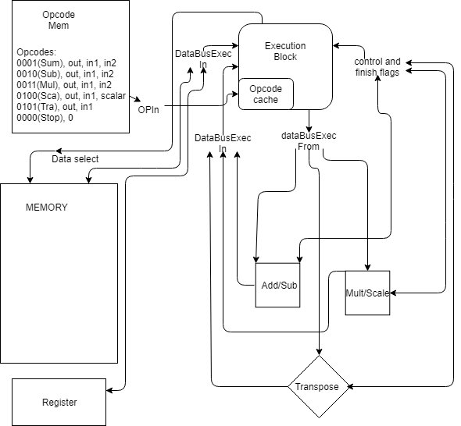

Exceptions:  
Stop; 000000000000000000000000000000000000000  
 Scalar; Reg/Mem not used for scalar